Organization Chart- PID Mechanical Maintenance

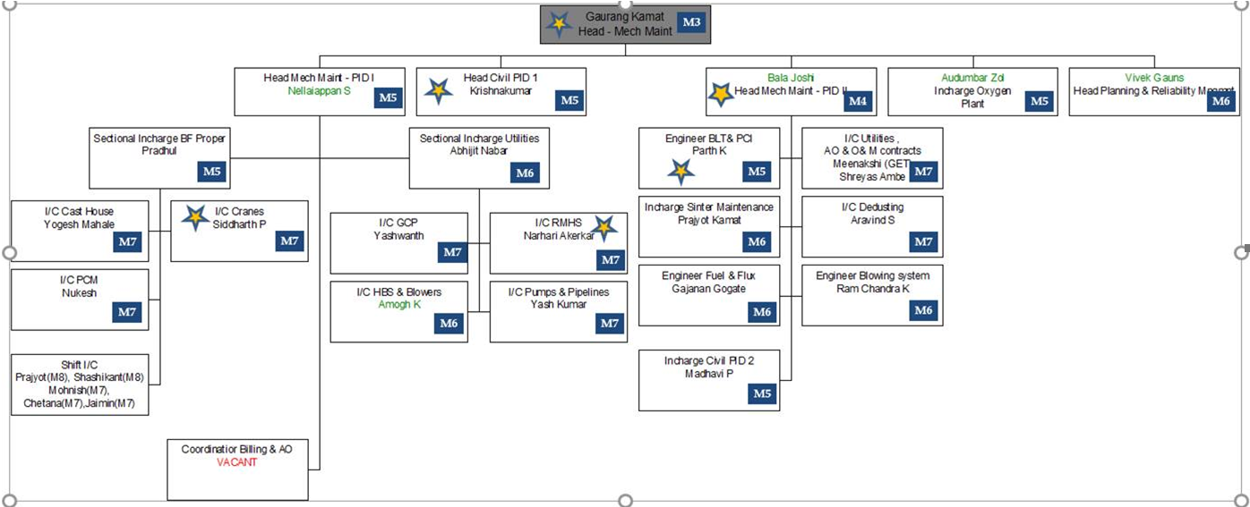

|  |  |  |
| --- | --- | --- |
| **Prepared By:**  Officer -BE | **Reviewed & Issued By:**  Management Representative | **Approved By:**  Head - Business Excellence VAB |
| **Signature:** | **Signature:** | **Signature:** |
| **Date: 03.01.2022** | **Date: 03.01.2022** | **Date: 03.01.2022** |